Project A

Add photos from different sources (Skydrive, Flickr, Facebook)

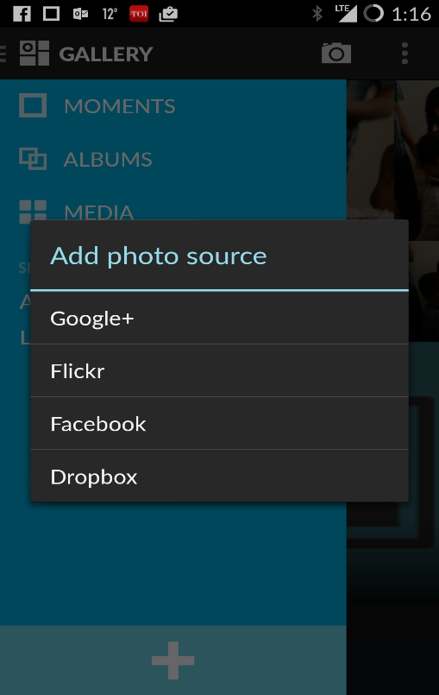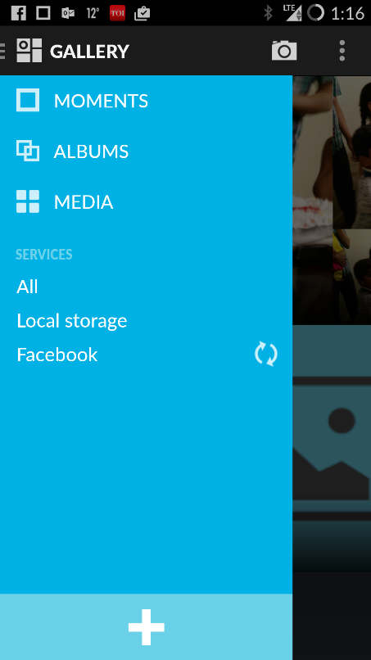

See Albums or All Photos in one view

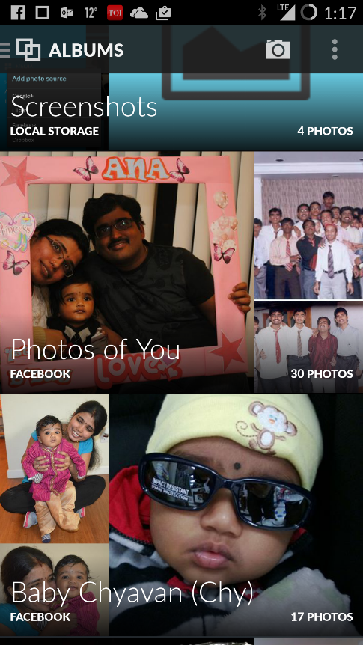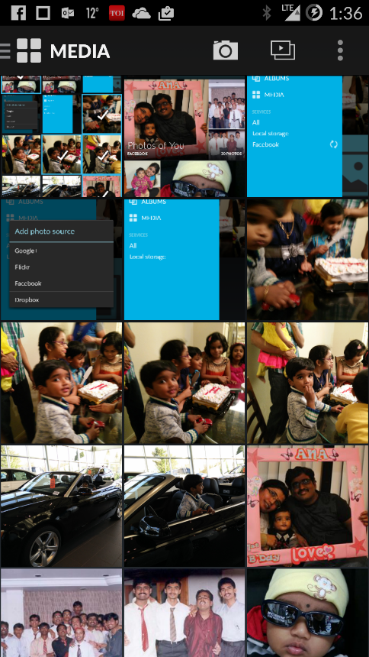

Perform operations (like download, delete, share etc) photos from different sources

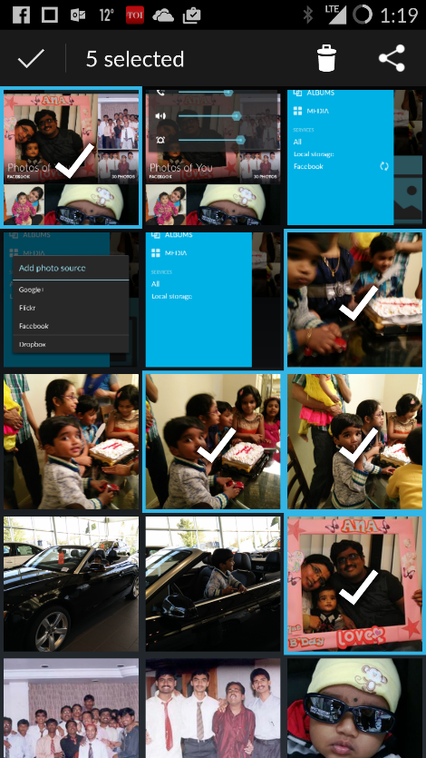

Photo Activity feeds (from Facebook, Flickr, Google+ etc.,).

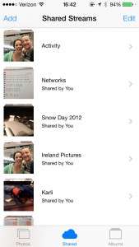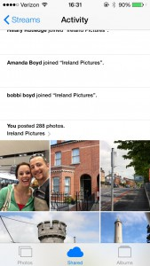

Like/Comment on photos irrespective of source



Creating Albums and uploading photos to a service?